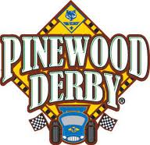

Rancho San Luis Rey ZONE – PWD OFFICIAL RULES

PARTICIPATION: Open to all Packs in RSLR Zone for qualifying Track for overall top honors. You must be present to race. Others may race on the non-official track for adults and anyone visiting from outside of the Zone for fun. We ask that you register your pack dens by either parent, Den Leader, and or cubmaster at https://ranchosanluisrey.weebly.com/pinewood-derby.html. If you have had your Pack (PWD) event signify the top three overall winners to compete for the Zone finals as these cars prequalify. If your Pack or dens have no track and want to race, to determine who qualifies for the overall winner will need to race from the hours of 10:30am - 12:00pm.

All cars are tech inspected prior to racing for adherence to the Pinewood Derby Specifications as listed below. Cars out of compliance will be given a chance to make corrections and go back through tech inspection until the end of the specified check in time. Once a car has been checked it will be registered for racing and will be impounded until the end of the race. Cars not qualified for the finals can be released back to the scout.

After tech inspection each registered car will be organized into heats and raced on the three lanes of the track. Heat times will be recorded, and a cumulative time will be tabulated. Cars will be ranked by overall time. A group of 15 cars with the lowest overall times will race in the finals with prequalified Pack winners to determine the top honors of the Rancho San Luis Rey Zone. Additional fun awards will be given to cars with Most Original, Best Paint Job, Most Patriotic, Best Cartoon Design, Best Powderpuff, Most Bedazzle, Best Food Design, Most Colorful, Best Military Design, Best Sporty Design, Most Unusual Design, and Slowest in the West.

Cars failing to remain in the assigned lane will not be allowed to continue racing in that heat. Any car that loses any of its parts will also not be allowed to continue racing. Repairs can be made but will have to go through tech inspection and registration again and then can be put back into the racing queue though the end of registration. Any car or part of a car interfering with another car on the track will not be allowed to continue in that heat. If a car has been interfered with, the run can be re-started without the interfering car. A maximum run time per car is set to 9 seconds. Cars failing to complete the track past the timing lights will be given the maximum run time of 9 seconds.

All Participants are expected to display good Scout Spirit at the Pinewood Derby. This applies to scouts, parents, siblings, and spectators. Yelling, heckling, foul language or arguing with race officials will not be tolerated. Persons not respecting these rules may be asked to leave the race.

Cars should be built by the Scouts with adult guidance. Technical assistance should be fully explained to the scouts so that he can use the knowledge in future races. Racing requires participants to learn two main things: the craft skills necessary to make your car and the rules that must be followed. There is also a third part to competition that's very important.... SPORTSMANSHIP. This has to do with how you act and behave while participating in the derby. You can’t use cars from past years

REMEMBER THE CUB SCOUT MOTTO - DO YOUR BEST. IT SAYS NOTHING ABOUT BEING PERFECT.

SCHEDULE TIME OF EVENTS

7:30am - Setup of the Area

8:30am - Troop Booths & Decorations Setup

9:00am - Pit crew Training & DJ Setup

9:30am - 11:30am Tech inspection and registration for morning qualifying heats

10:00am – Opening Ceremony

10:30am - 11:30am Tech inspection and registration for Pack's top 3 finishers who already held their local PWD

10:30am - 2:00pm Morning qualifying heats

11:30am - 12:00pm - Lunch Break or Break

2:30pm - 3:30pm Finals & Awards

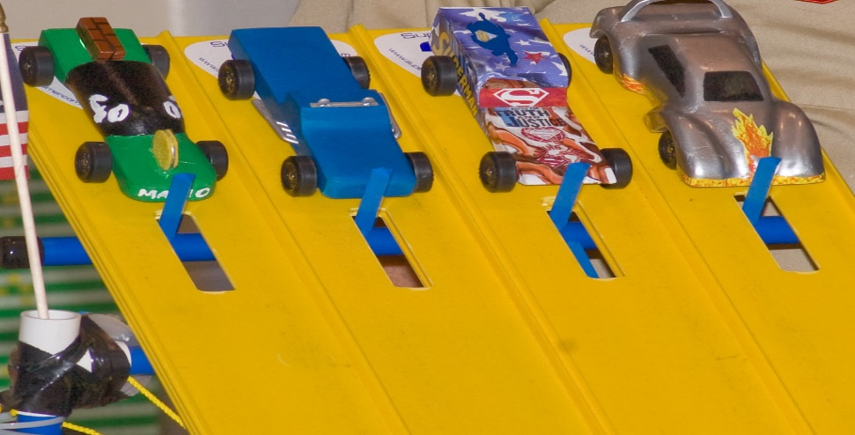

Pinewood Derby Specifications:

All cars are tech inspected prior to racing for adherence to the following rules. Cars out of compliance will be given a chance to make corrections and go back through tech inspection until the end of the specified check in time. Once a car has been checked in it will be impounded until the end of the race.

The Rules Source https://www.sandiego500.org/specs/

1. WIDTH: Overall width of the car, including wheels, shall not exceed two and 3/4 inches (2.75"). The body width where the axles attach to the wheels shall not be less than one and 3/4 inches (1.75").
2. LENGTH: Overall car length may not exceed seven inches (7.00"). The kits often supply wood blanks longer than 7 inches.
3. HEIGHT: Overall car height may not exceed three inches (3.00"). This prevents tall cars from crashing into the finish line and electronic lane judge.
4. WEIGHT: Total weight of the car shall not exceed five (5.000 oz) ounces. (Verified by certified scale)
5. WHEELS: Only official Boy Scout Grand Prix racing wheels are allowed. All four (4) wheels must be used. Wheels may not be altered (rounded across the tread-surface, narrowed etc.) except for the removal of burrs. Wheels may not be lathe-turned, thinned, sawed, perforated or machined in any way. Outside wheel diameter should be no less than 1.175". Ready-made modified wheels are not allowed. Wheels must be attached so that there is a minimum of .375" (3/8") between the car bottom and the rolling surface to provide track lane-guide clearance. Color wheels (Red, Yellow, Orange, Blue and the original Black) are all legal wheels as long as they are the official "BSA PINEWOOD DERBY" wheels. Cubs may correct wheel hubs and axle openings using hand tools and jigs. Only the wheels of a pinewood car may touch the surface of the track and the associated lane guide. If a vehicle fails its "wheels inspection" and they are removed to be replaced, the axles will be subject to closer inspection to confirm compliance with the rules.
6. AXLES: Only official BSA Grand Prix Pinewood Derby metal "nail" type axles are permitted. Axles may be polished and lubricated but the use of wheel bearings, washers or bushings is strictly prohibited. Paper label 'hubcaps' may be used but the head ends of the axles must be made available for judging when requested. Precision machined axles, notched axles, and axles of alternative metals (like stainless steel) are not permitted. Removal of burs under the nail head is permitted.
7. LUBRICANTS. Only dry lubricants such as graphite, graphite with Molybdenum, or BSA "AXLE LUBE" are allowed. Oils or other wet lubricants are not permitted, even if sold at the Scout Shop.
8. SPRINGS: The car shall not ride on any type of spring or other suspension.
9. PROPULSION: The car must be freewheeling and may not contain any type of auxiliary propulsion or utilize any type of starting device. (No jets, rubber bands, magnets, hooks, adhesives, springs, motors etc.)
10. DECORATIVE DETAILS: may be added provided they do not exceed the maximum weight and dimensions for the car. (Decals, trim, characters and decorations are allowed if they meet the finished car size and weight rules.)
11. NO LOOSE MATERIALS: The car may be hollowed-out and built up to the maximum weight by the addition of wood or metal. Any additional materials must be securely built into the body or chassis. Mercury shall not be used for weight addition or other construction purposes as it is a health hazard.
12. MATERIALS: Cars must be built using the BSA Grand Prix Pinewood Derby Series Car Kits. Additional metal must be used only for weight addition or decoration. Axles must be mounted into the wood body. No portion of other kits will be allowed except for decorative purposes. Structural strength is gained only from the wood body. No metal frames or metal axle support is permitted.

